# NNF

## Method of NNF

**Task:** Optimize all 7 parameters: {delta, Amax, Vmax, Ka, alpha, Km, beta_max}

**Criteria: (new criterion highlighted)**

1. Relative amp of Ptot > 0.5

2. max(Ptot) is minimized s.t Kd is maximized

~~3. BMAL (At) average level matches SNF model~~

4. Relative amp of BMAL > 0.2

~~5. Period of Ptot matches SNF~~

6. max(Rev) < 10

7. max(AT) / max(Ptot) as close to 1 as possible

**Method**: simulated annealing with fmincon for the final step; Options: {'TemperatureFcn','temperatureboltz', 'AnnealingFcn','annealingboltz'}

**Cost function:**

**Range of search:**

**Initial guesses:**

Random samples with Latin hypercube in the range above for the logarithm values of the parameters.

**Sets of runs:**

1. Previous: 1009 runs w/o criterion for max(AT);
2. New: 1011 runs w/ additional criterion for max(AT);
3. NNFd2: 934 runs w/ separate delta_AT and delta_V, and w/ additional criterion for max(AT);

## Results of NNF

### Distributions of output metrics

**Previous:** 1009 runs w/o criterion for max(AT)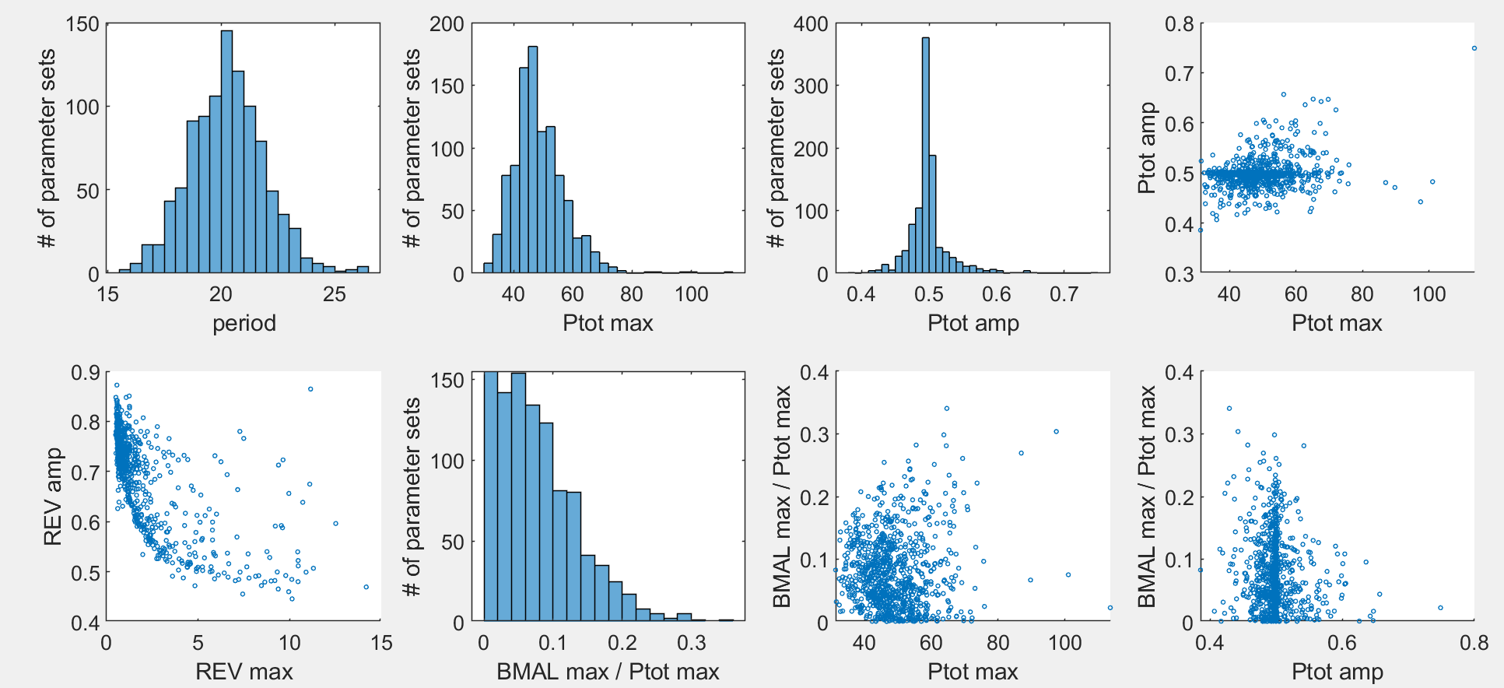

**New:** 1011 runs w/ additional criterion for max(AT)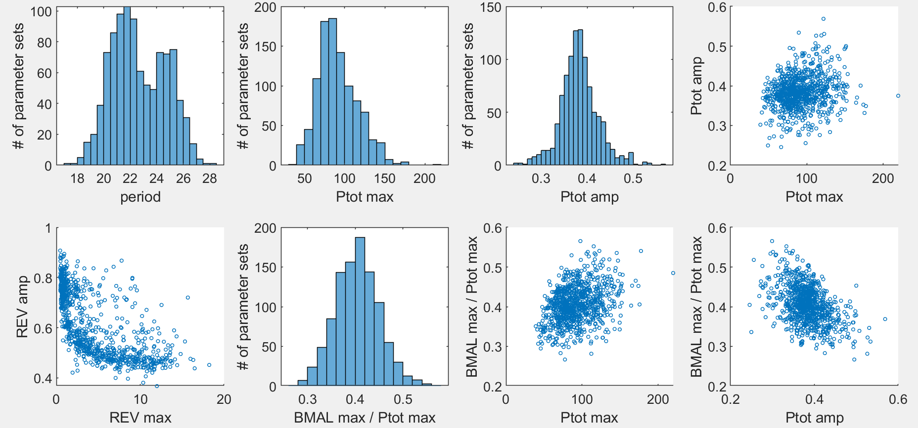

**NNFd2:** 934 runs w/ separate delta_AT and delta_V, and w/ additional criterion for max(AT)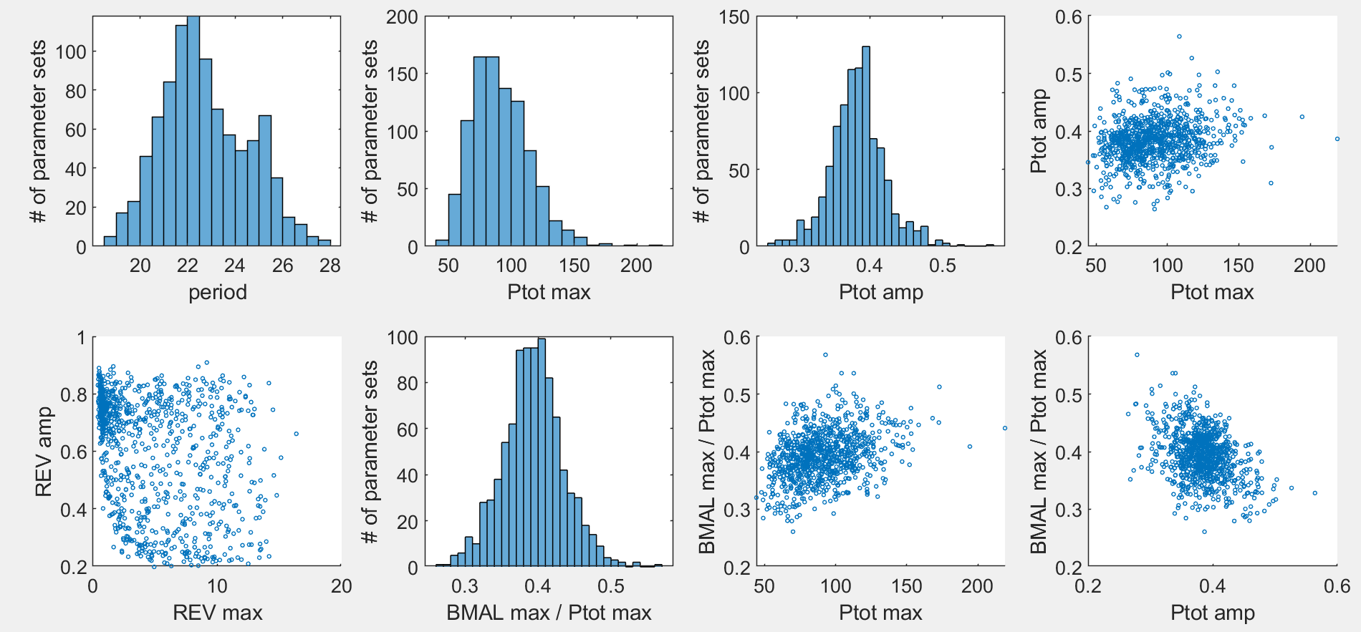

Observations:

1. Amp(Ptot) can hardly exceed 0.5 in the new sets, whether or not delta_AT and delta_V are separate. Note: this does not necessarily mean that the five-point criterion won’t be satisfied.
2. Desired max(BMAL)/max(Ptot) (as close to 1 as possible) does conflict with the desired max(Ptot) (as small as possible) and amp(Ptot) (as large as possible).
3. The following plots show data of the points with the best combination between max(BMAL)/max(Ptot) and max(Ptot). Xiangyu may check how their corresponding 2-param bifurcation diagrams look.

|  |  |
| --- | --- |
| Original NNF | NNFd2 |
|  |  |

### Patterns of optimized parameter sets

**Previous:** 1009 runs w/o criterion for max(AT)

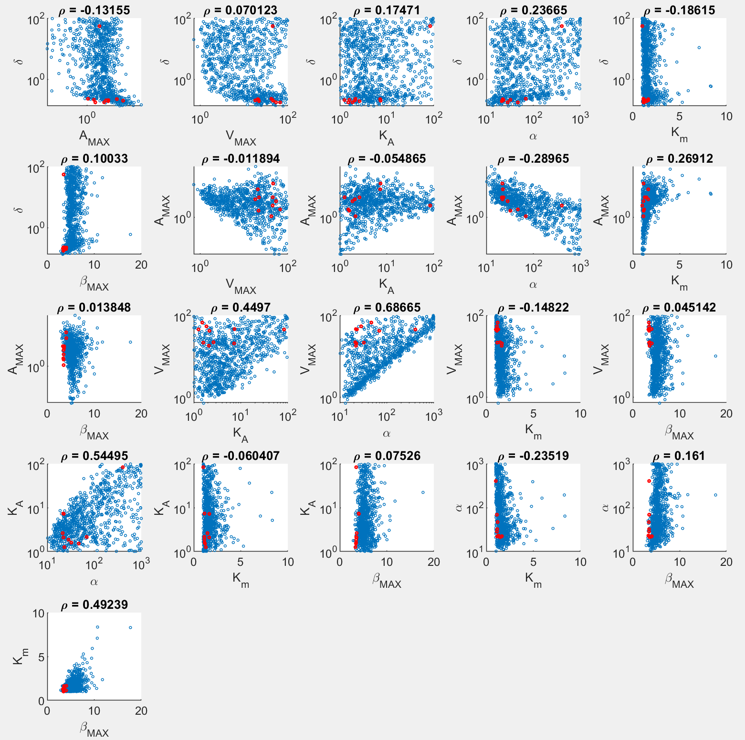

**New:** 1011 runs w/ additional criterion for max(AT)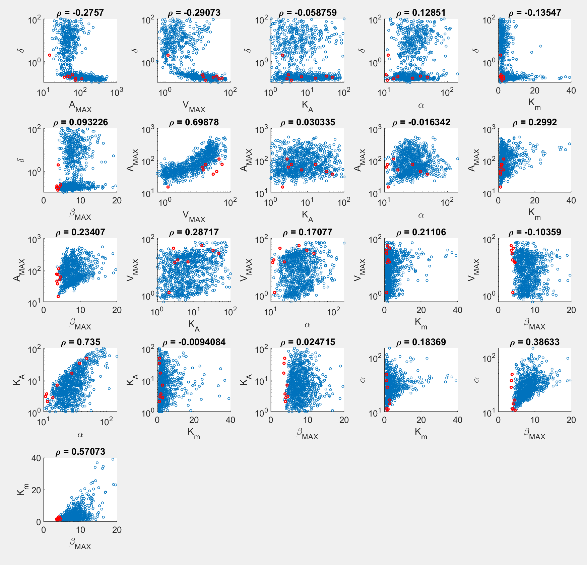

Main patterns:

1. The new set presents more cases with small delta, large Amax (obviously, to increase max(AT)), smaller alpha (to lower max(Ptot) relatively to max(AT)), and more spread distribution of Km;

**NNFd2:** 934 runs w/ separate delta_AT and delta_V, and w/ additional criterion for max(AT)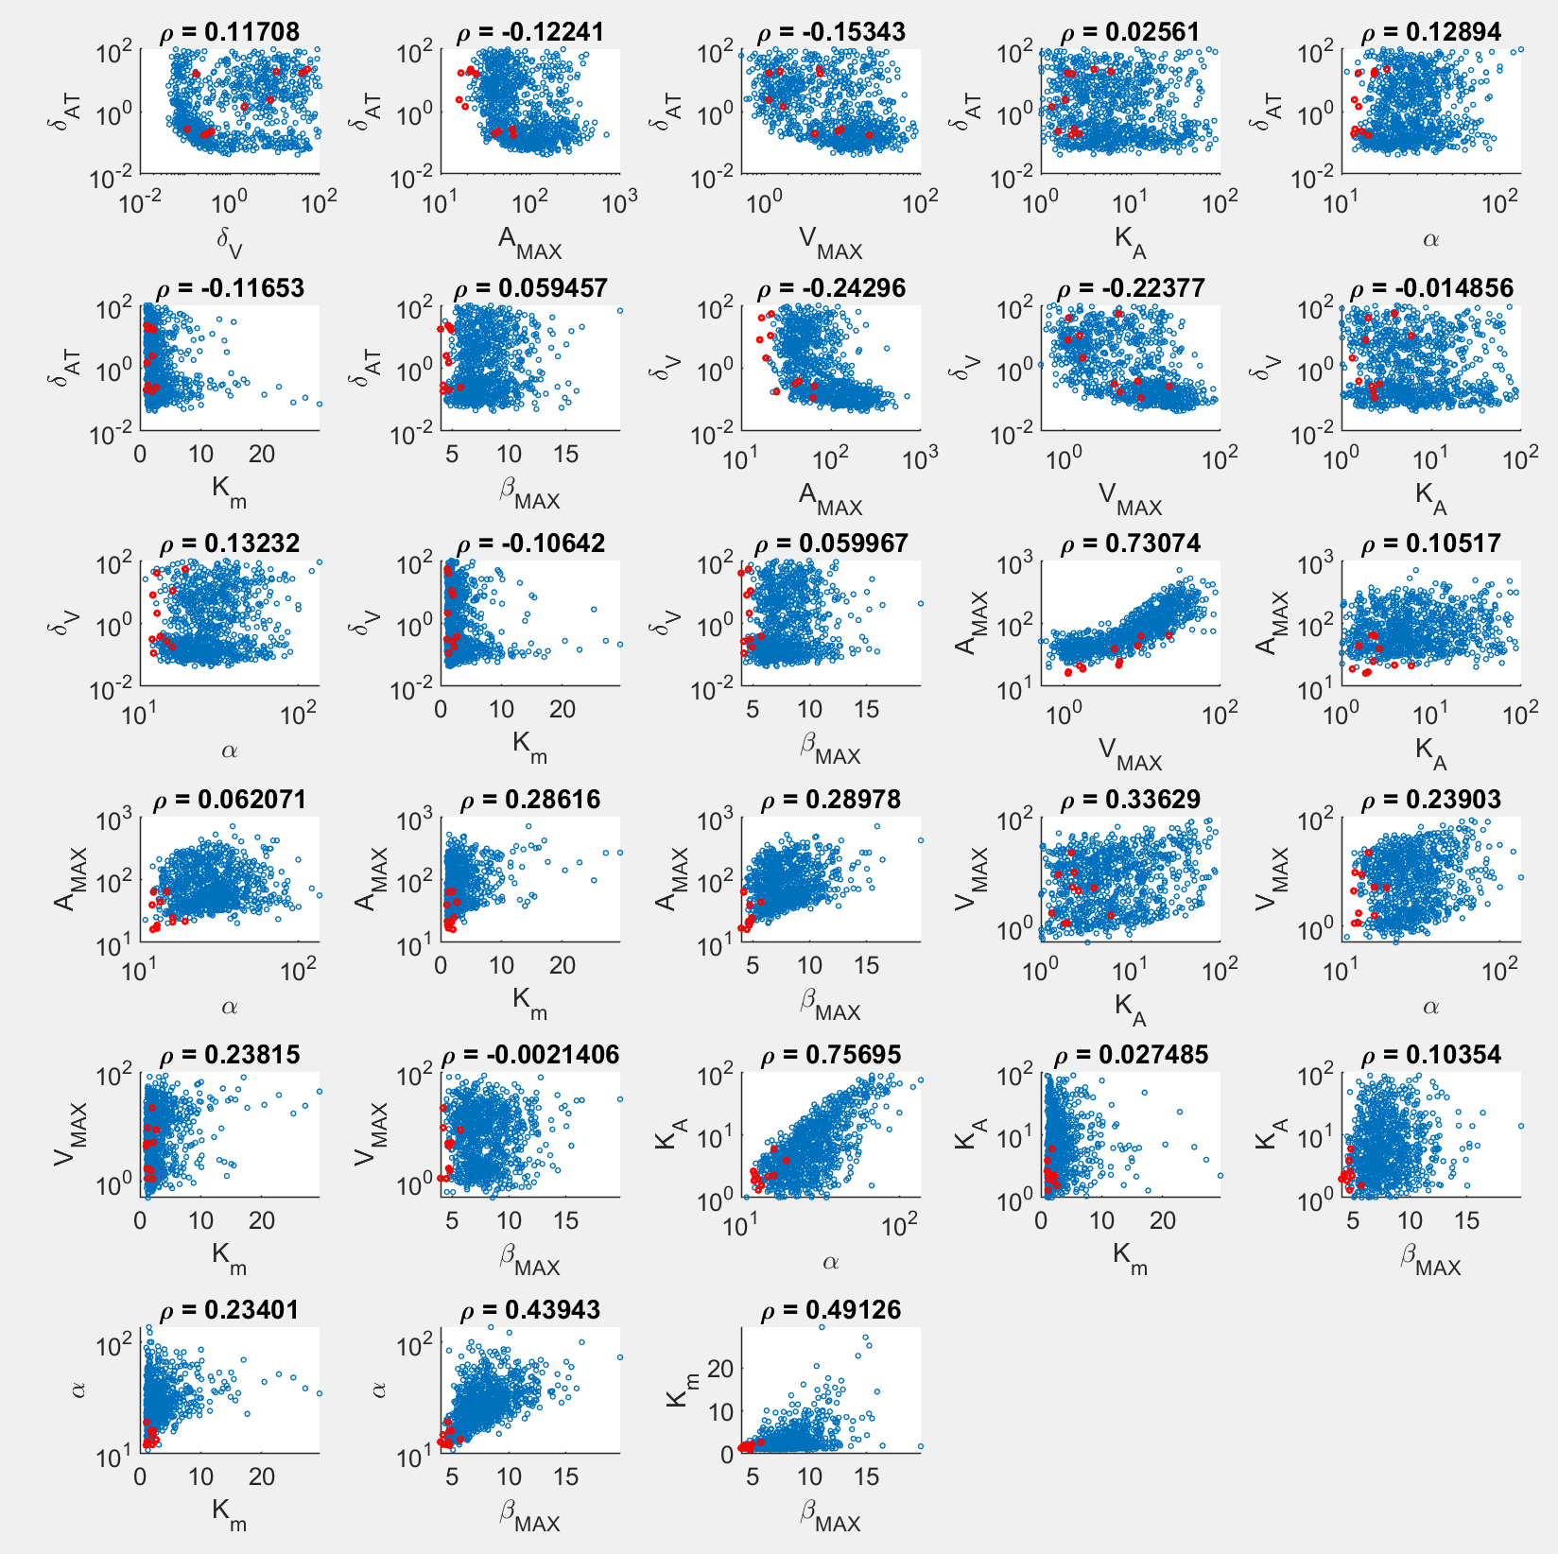

Main patterns:

1. Delta_AT and delta_V are distributed spreadly;
2. Distributions of the other parameters are the same as the original NNF model;
3. Bottom line: NNFd2 does NOT help.

### Correlations between parameters and output metrics

**Previous:** 1009 runs w/o criterion for max(AT)

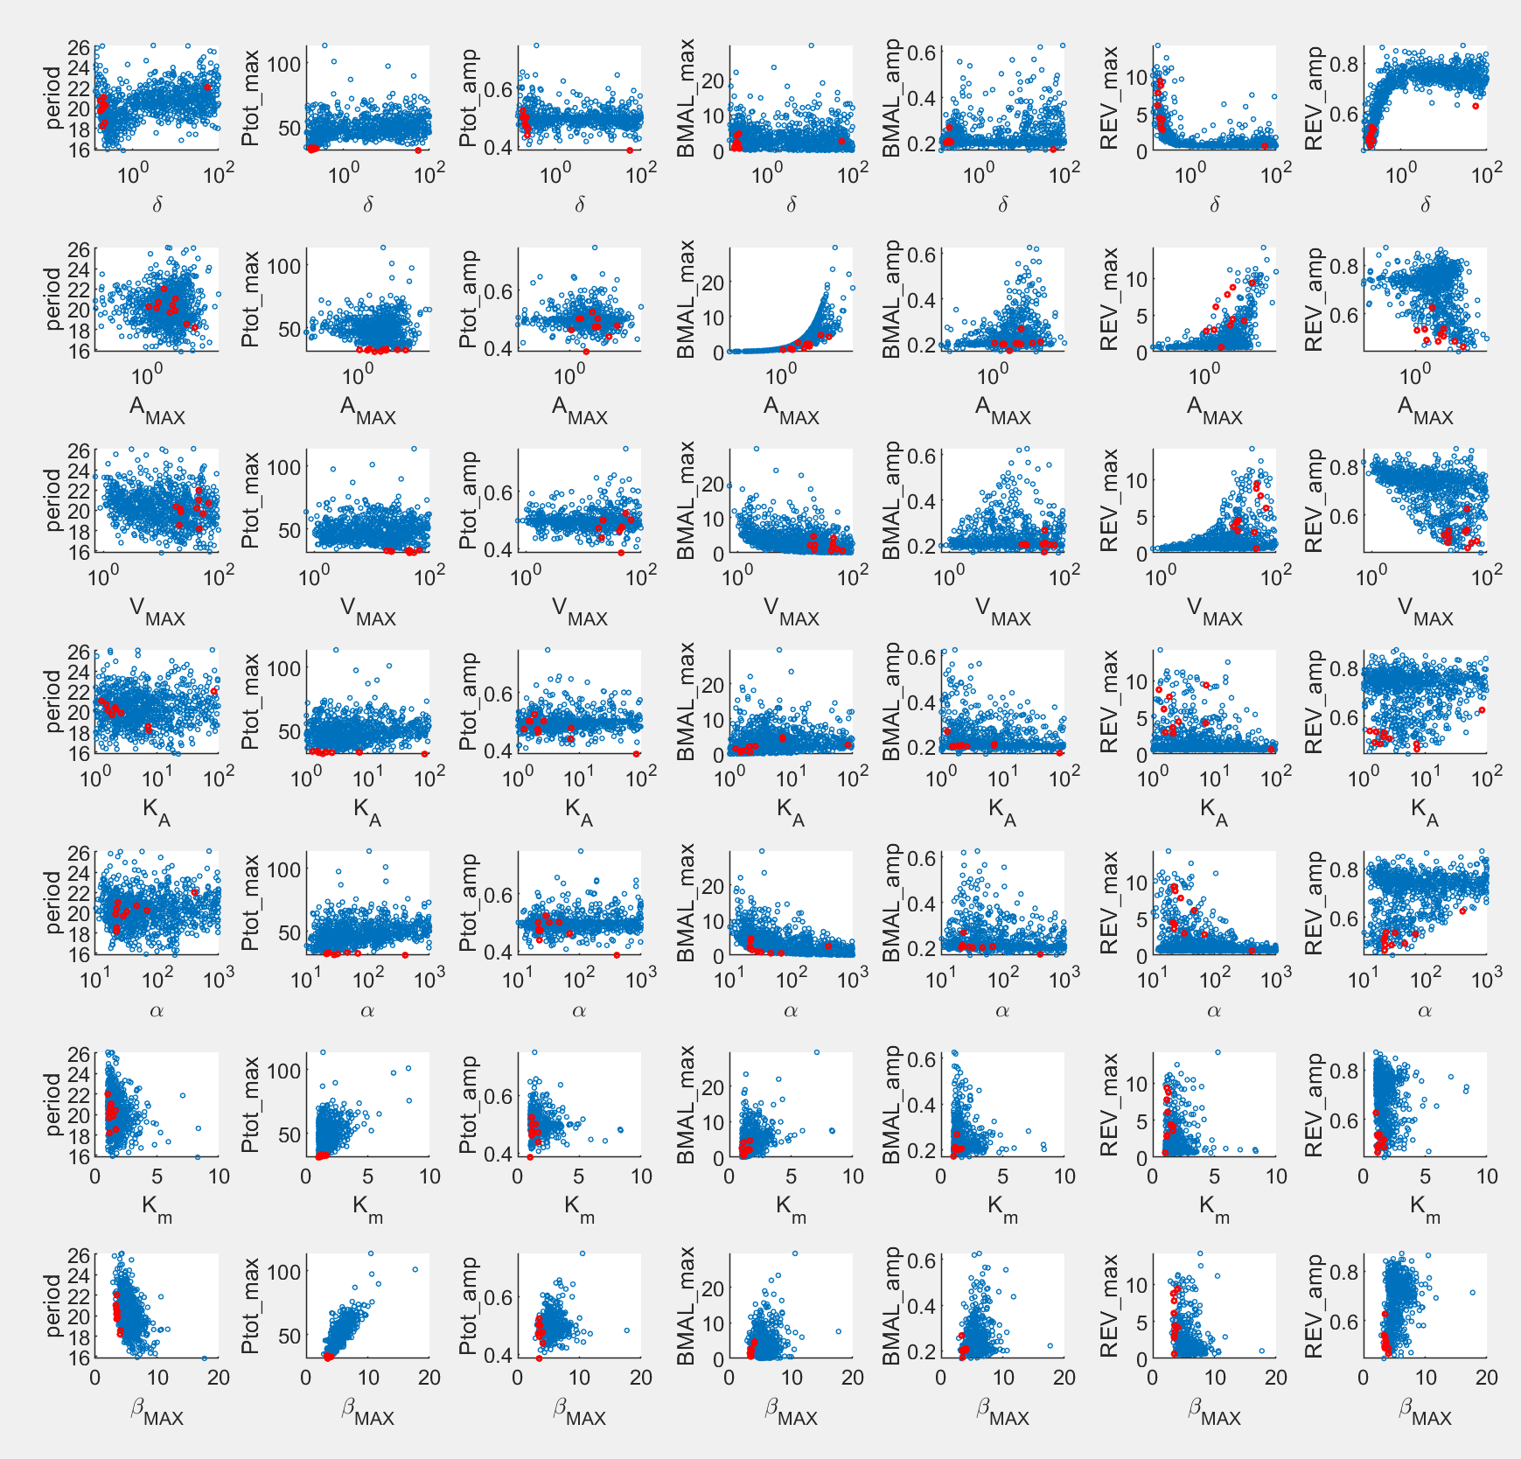

**New:** 1011 runs w/ additional criterion for max(AT)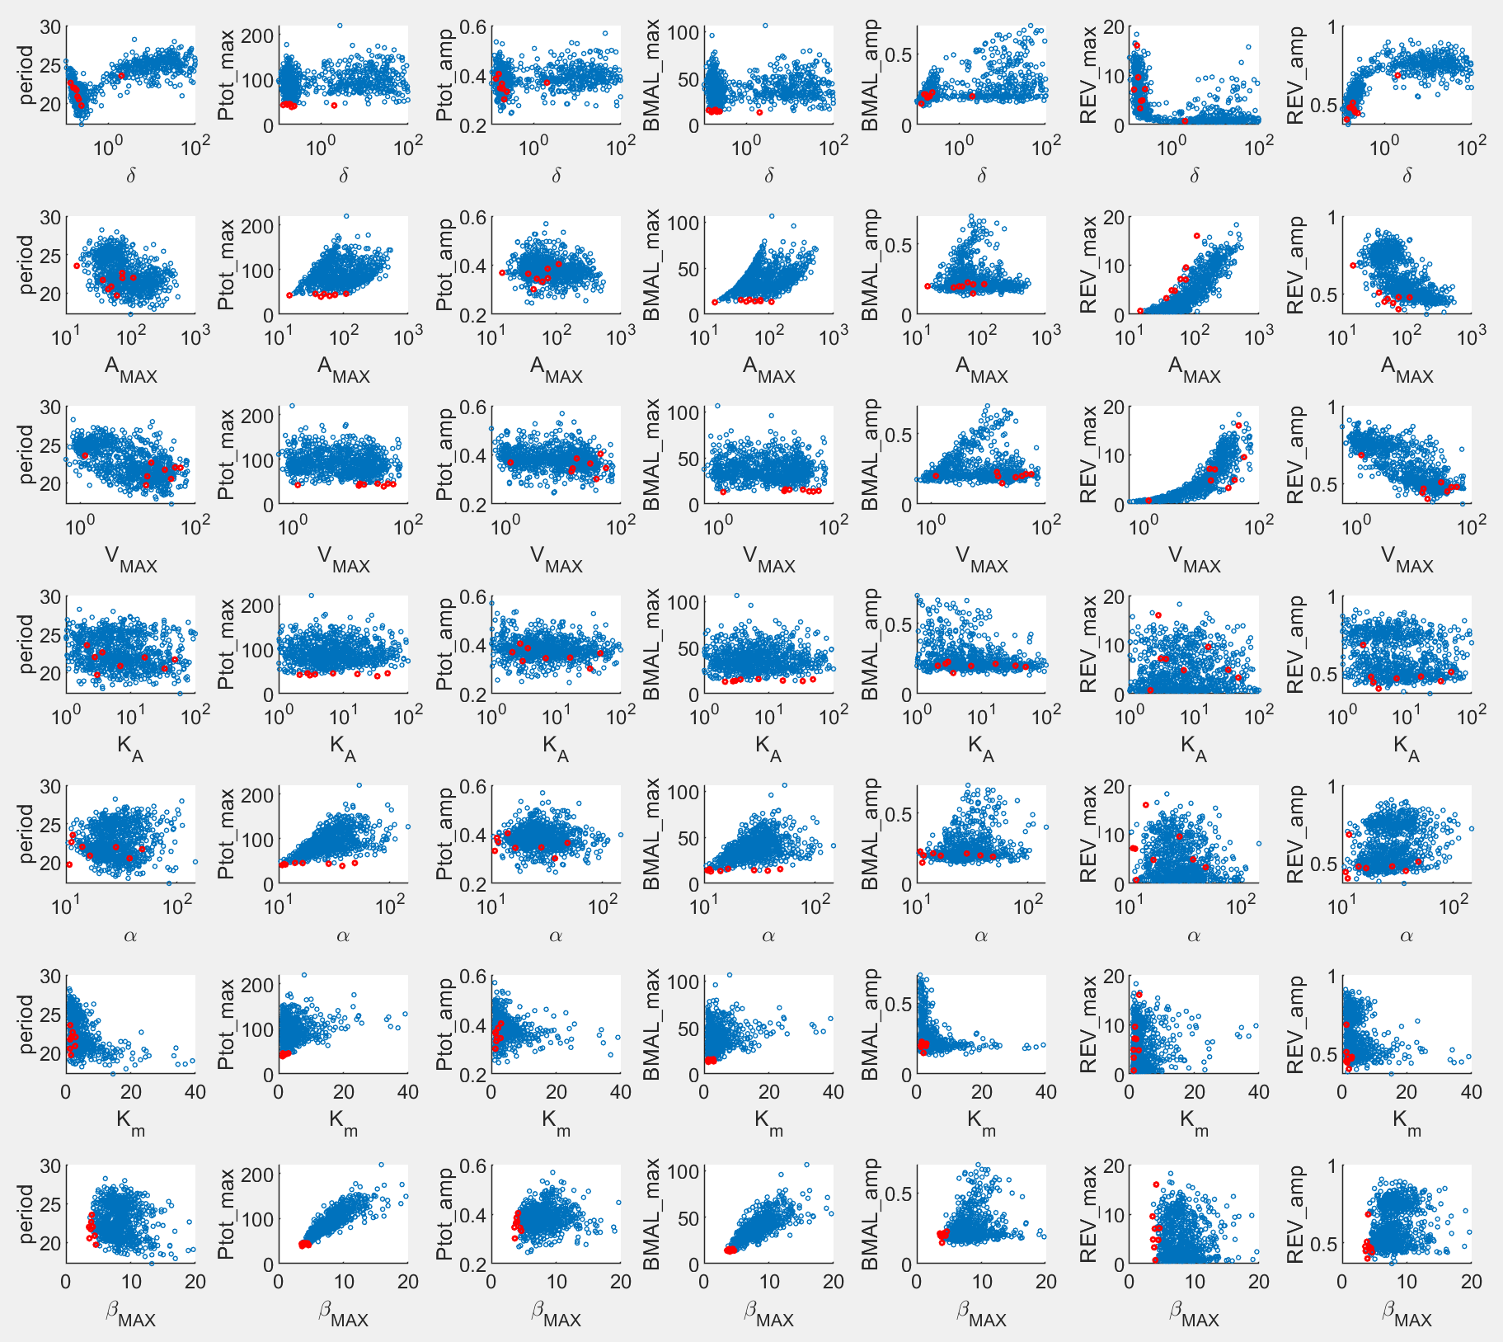

Pattern:

1. Max(Ptot) and max(BMAL) are most sensitive to beta_max, followed by alpha and Km.
2. Delta is apparently concentrated in two clusters.
3. Patterns are similar between two sets, except that the ranges of max(Ptot) and amp(Ptot) are less desirable, when max(BMAL) is improved.

**NNFd2:** 934 runs w/ separate delta_AT and delta_V, and w/ additional criterion for max(AT) 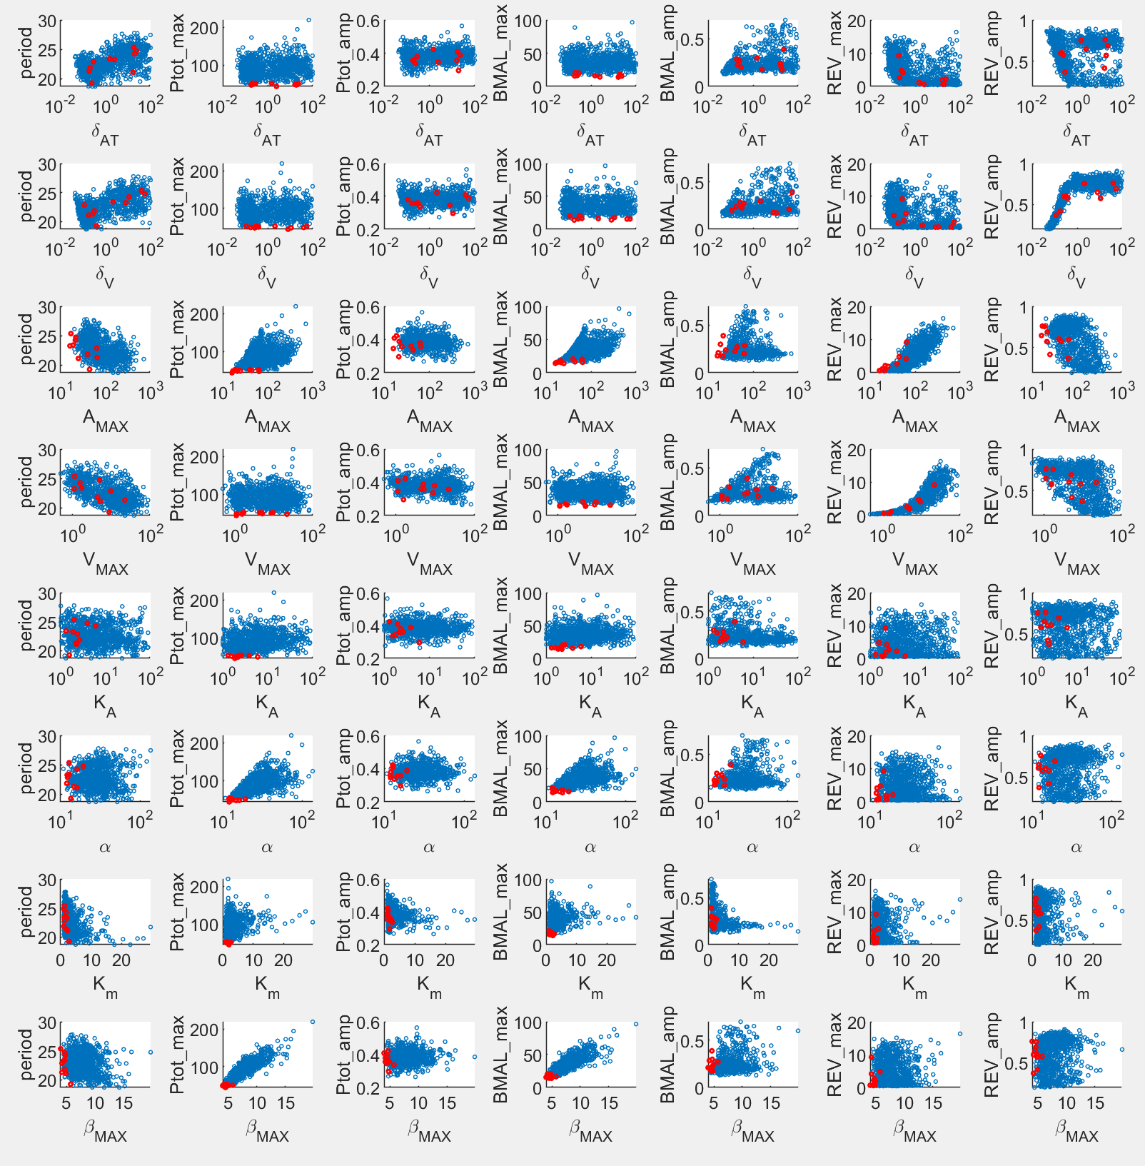

Again, NNFd2 does NOT make much difference.

If anything, REV_amp is more sensitive to delta_V, as expected.

# PNF

## Method of PNF

**Task:** Optimize all 8 parameters: {delta, Amax, Rmax, Ka, alpha, Km, beta_max, eps*}

* eps is the parameter that prevents zeros to be the steady state.

$$\frac{dA_{T}}{dt}=δ\left(A_{MAX}\frac{ε+R}{1+R}-A_{T}\right)$$

**Criteria:**

1. Relative amp of Ptot > 0.5

2. max(Ptot) is minimized s.t Kd is maximized

~~3. BMAL (At) average level matches SNF model~~

4. Relative amp of BMAL > 0.2

~~5. Period of Ptot matches SNF~~

6. max(Ror) < 5

7. max(AT) / max(Ptot) as close to 1 as possible

**Method**: simulated annealing with fmincon for the final step; Options: {'TemperatureFcn','temperatureboltz', 'AnnealingFcn','annealingboltz'}

**Cost function:**

**Range of search:**

**Initial guesses:**

Random samples with Latin hypercube in the range above for the logarithm values of the parameters.

**Sets of runs:**

1. Previous: 1016 runs w/o criterion for max(AT);
2. New: 952 runs w/ additional criterion for max(AT);
3. PNFd2: 1014 runs w/ separate delta_AT and delta_R, and w/ additional criterion for max(AT);

## Results of PNF

### Distributions of output metrics

Previous: 1016 runs w/o criterion for max(AT) 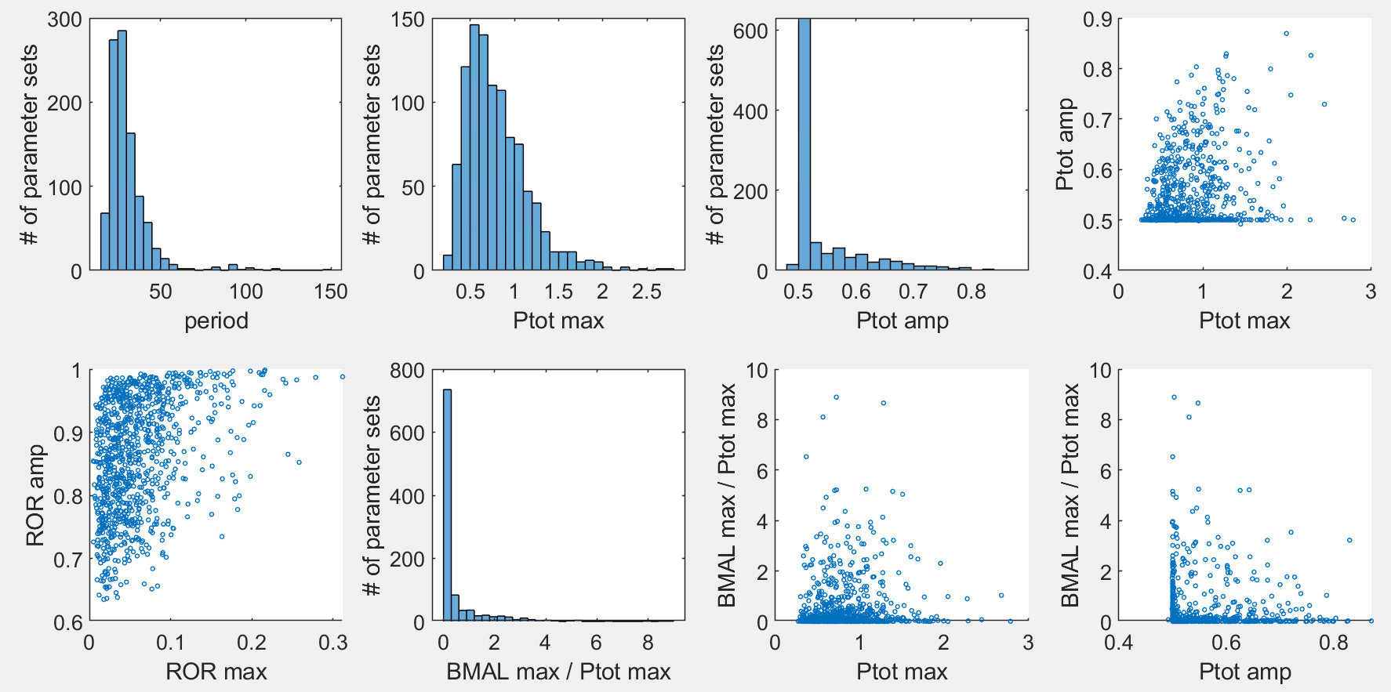

Surprisingly, in the previous datasets we have many sets with large max(BMAL)/max(Ptot) and perfectly good max(Ptot).

New: 952 runs w/ additional criterion for max(AT) 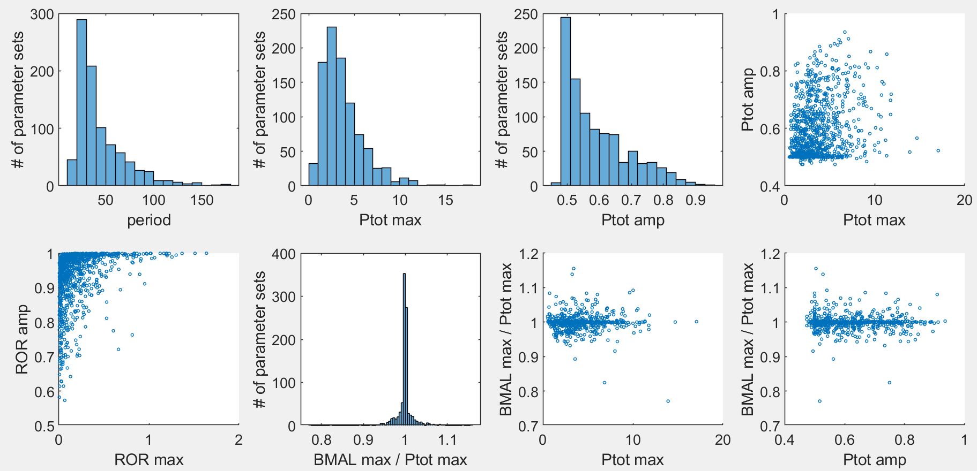

Xiangyu can look up the Excel file to find sets with small max(Ptot) and max(BMAL)/max(Ptot) close to 1.

PNFd2: 1014 runs w/ separate delta_AT and delta_R, and w/ additional criterion for max(AT) 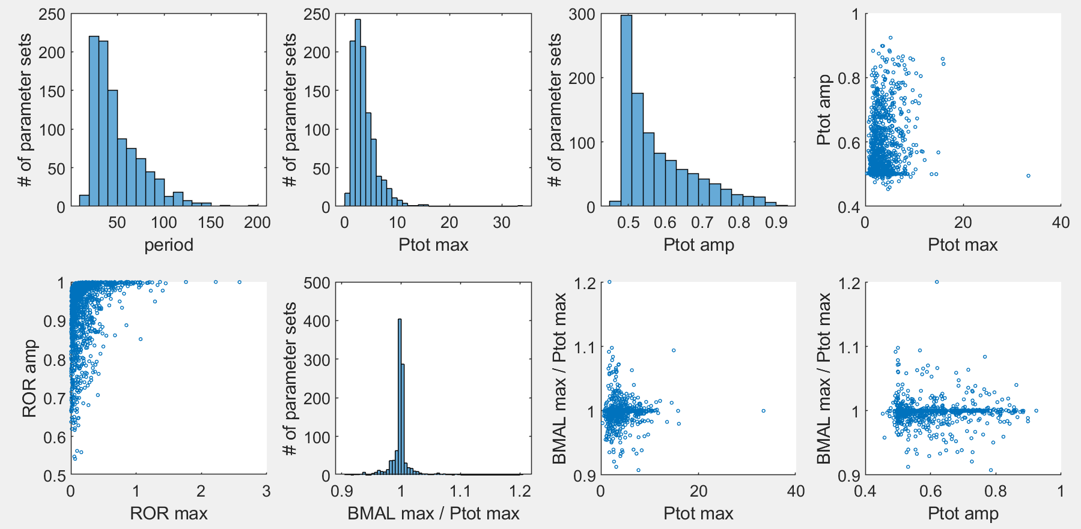

Not much difference from the model with one delta.

### Patterns of optimized parameter sets

Previous: 1016 runs w/o criterion for max(AT) 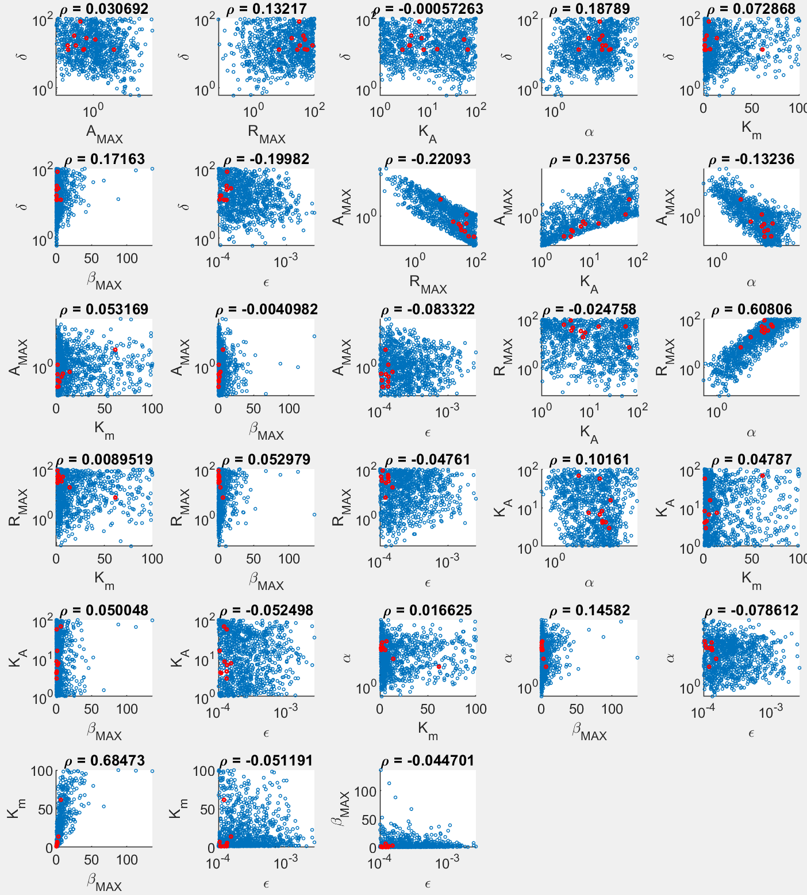

New: 952 runs w/ additional criterion for max(AT) 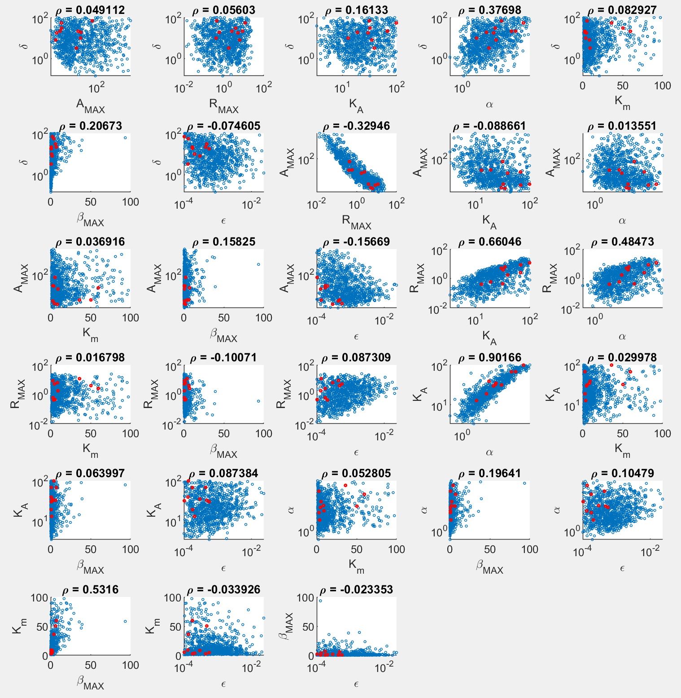

Main patterns:

1. The new set favors larger Amax (obviously, to increase max(AT)) and slightly larger Rmax;
2. In the new set, KA becomes correlated with Rmax and alpha, while Rmax and alpha are already correlated in the previous set;
3. Overall, PNF still easily gives sets that fit our criteria. To make BMAL level more equal to PER level, just need larger Amax and a more finely tuned KA.

PNFd2: 1014 runs w/ separate delta_AT and delta_R, and w/ additional criterion for max(AT) 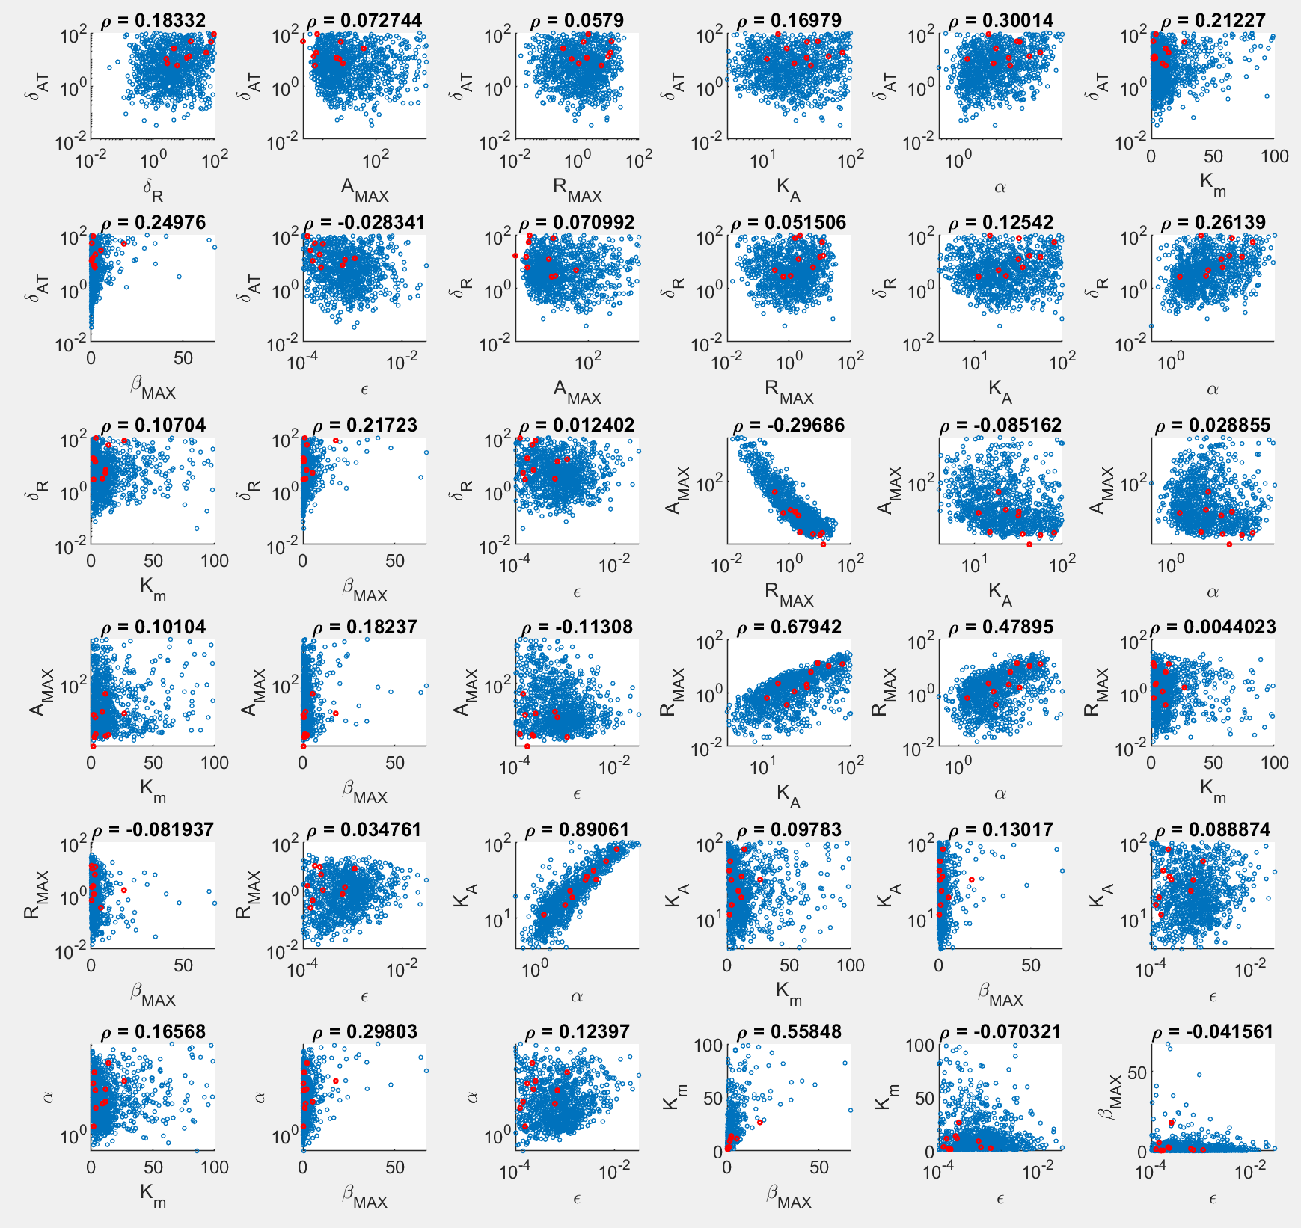

Main patterns:

1. Delta_AT and delta_R are distributed spreadly;
2. Distributions of the other parameters are the same as the original PNF model;
3. Bottom line: PNFd2 does NOT help.

### Correlations between parameters and output metrics

Previous: 1016 runs w/o criterion for max(AT) 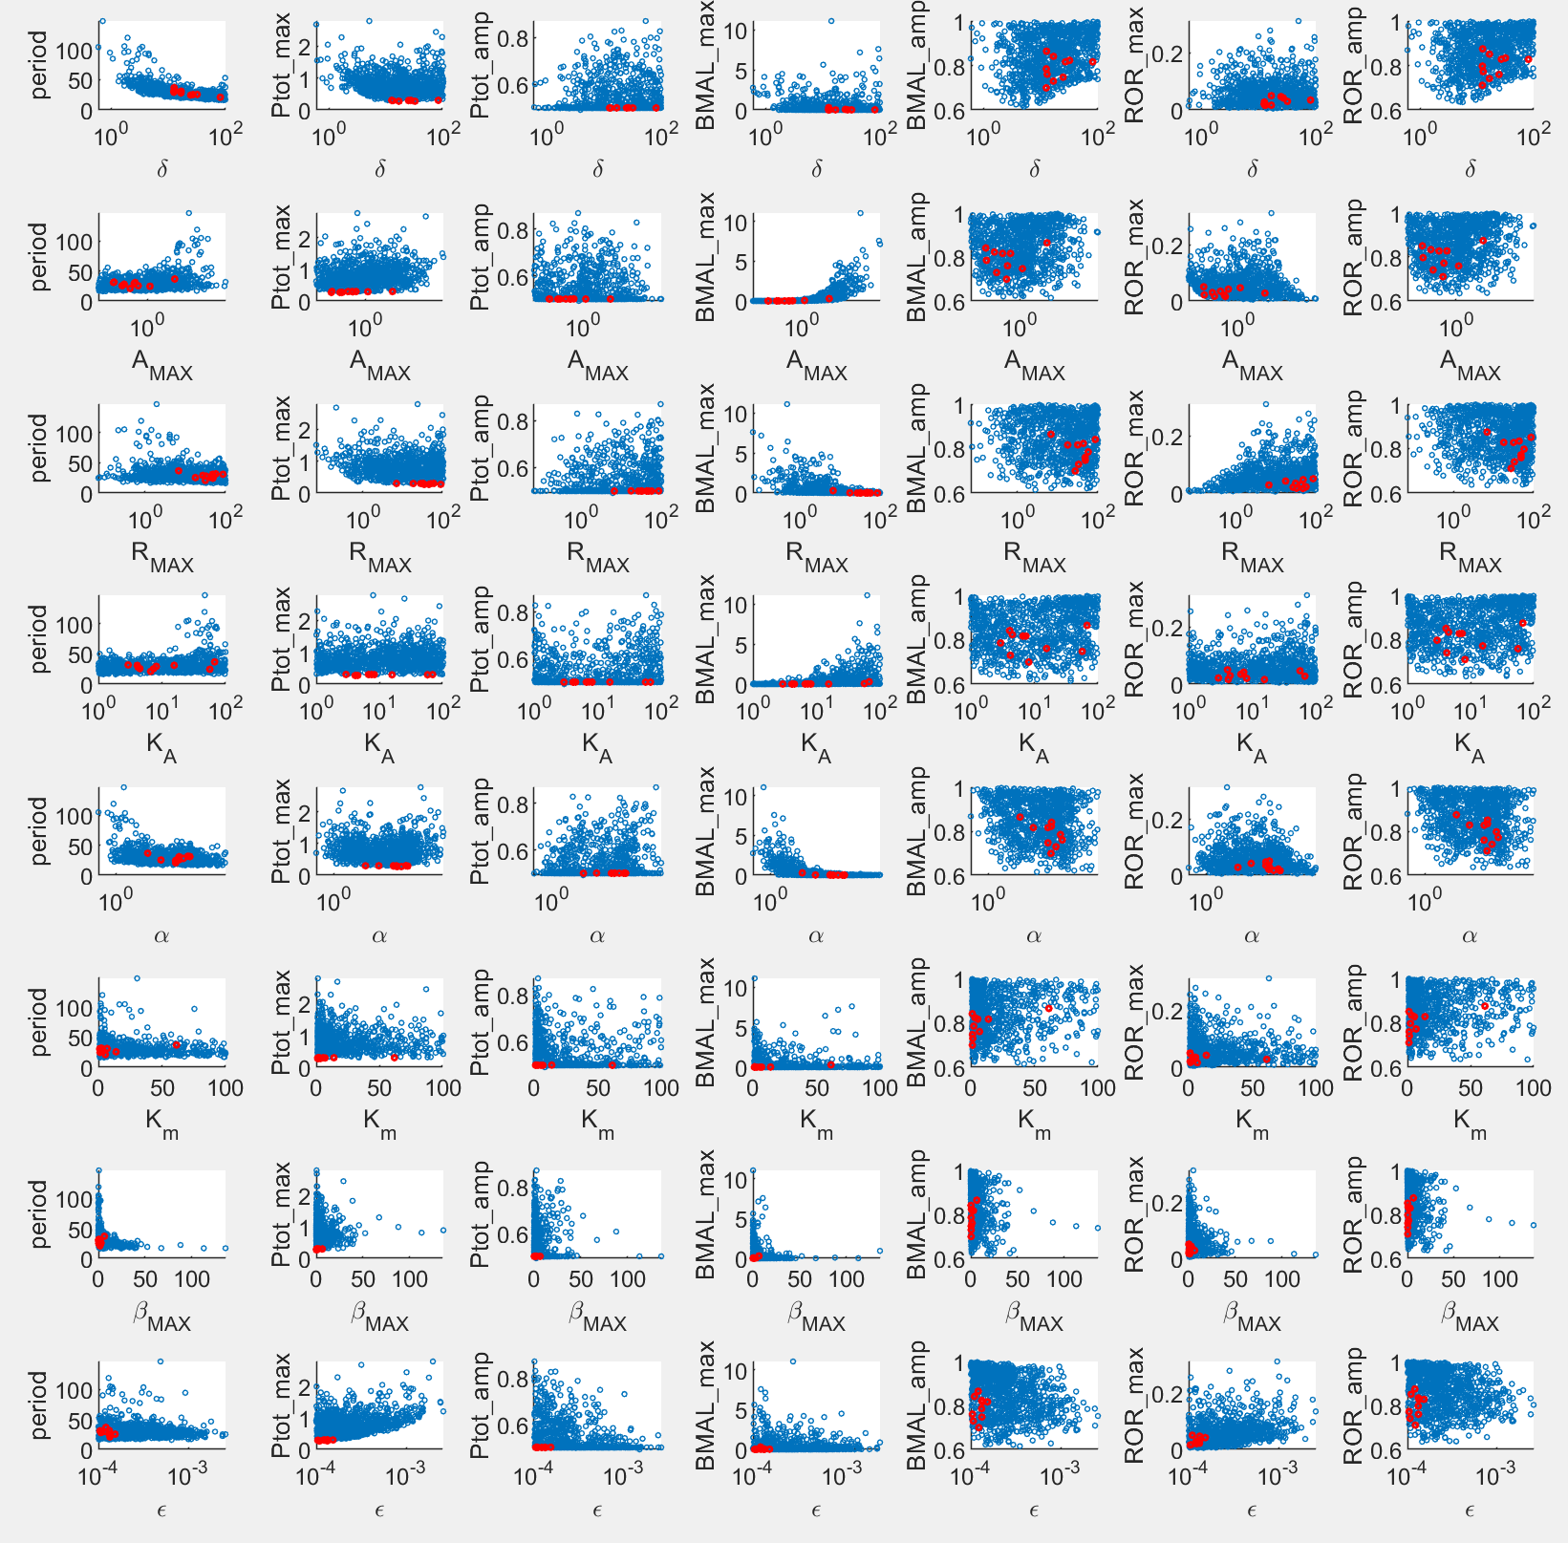

New: 952 runs w/ additional criterion for max(AT) 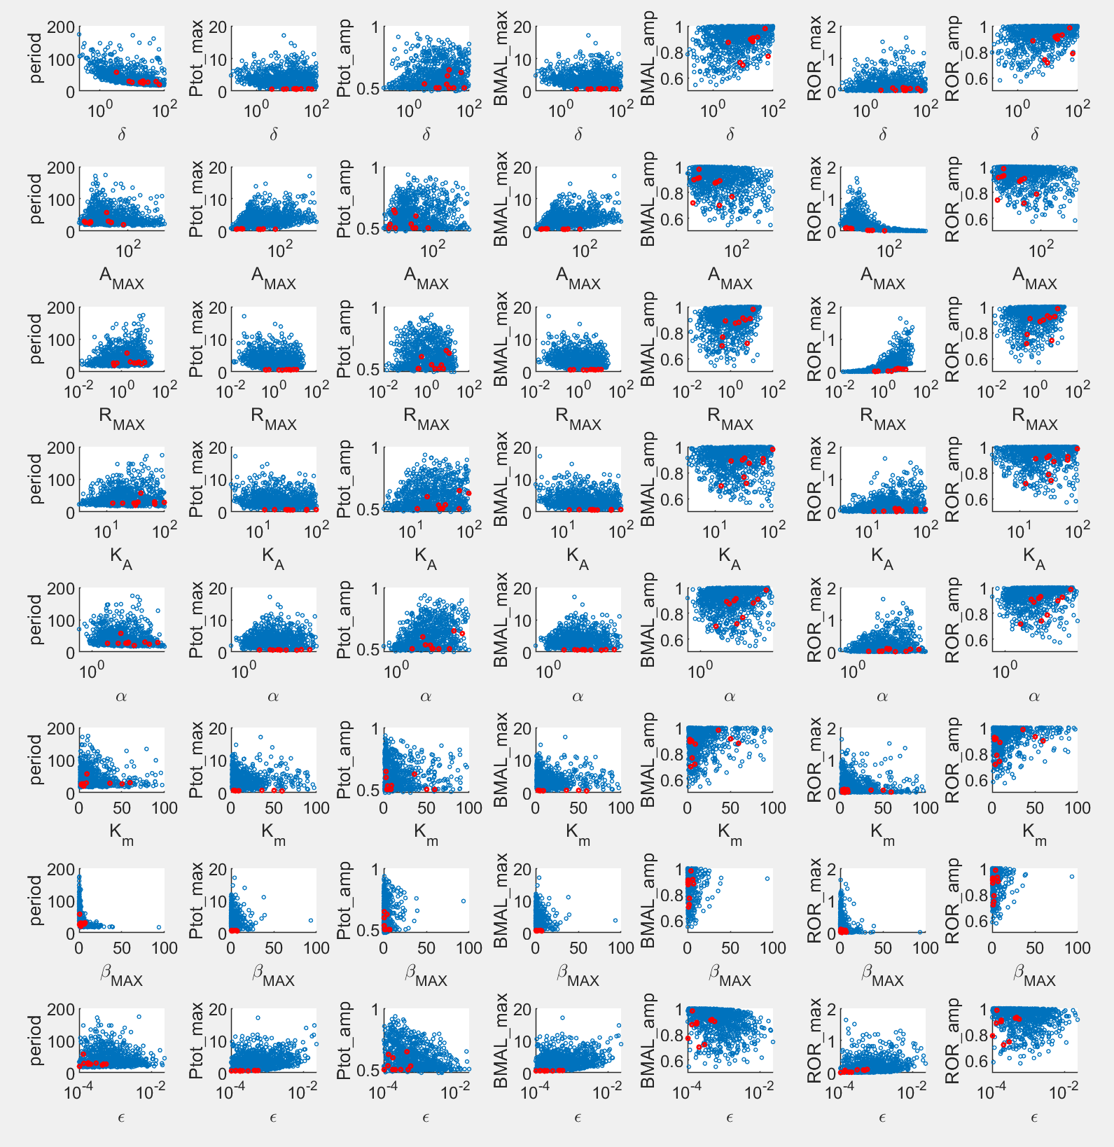

PNFd2: 1014 runs w/ separate delta_AT and delta_R, and w/ additional criterion for max(AT) 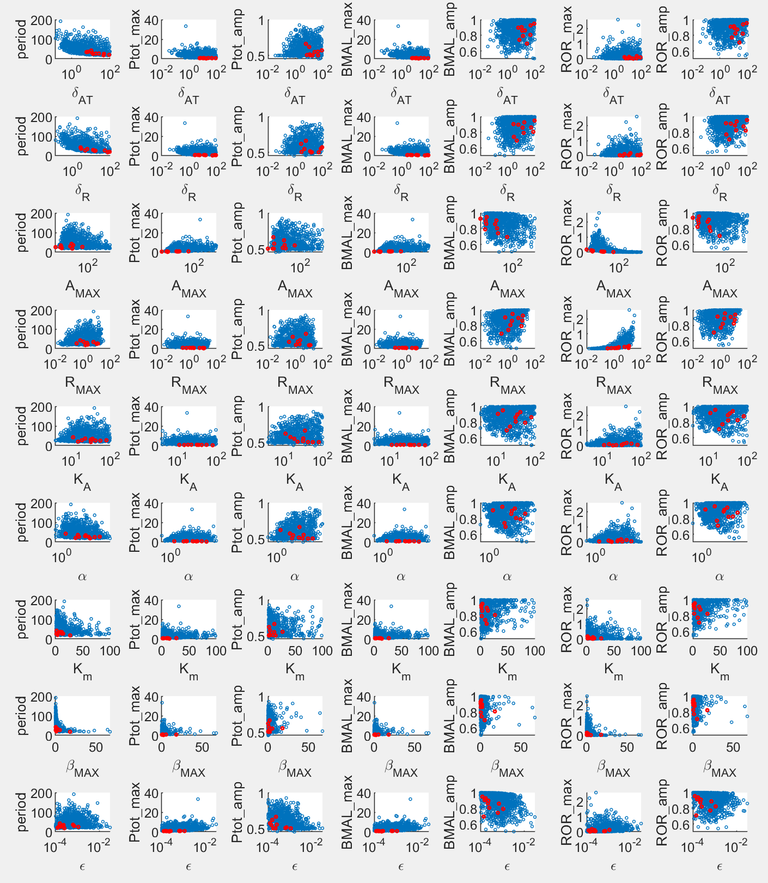

Again, PNFd2 does NOT make much difference.